Family Practice Skills Course #86
Contemporary Type 2 Diabetes Management - What’s New?
Polling
1. What is your current 1st add-on for T2DM after metformin?
- SU
- DPP4i
- SGLT2i

Polling
2. In terms of treatment for diabetes, which of the following are important (limiting to 3 most important) treatment goals to you?
- Reduction of HbA1C
- Primary prevention of heart failure hospitalization
- Primary prevention of new & worsening nephropathy
- Reduce mortality
- Prevent MI
- Treatment tolerability

Polling
3. What is stopping you from adopting SGLT2i, for your T2DM patients?
- Current treatment already gives good glucose lowering
- Not sure how to use
- Side effects
- Cost

FPSC 86 -- CASE 1
Mr A. Age: 68 years, seen on 21 Aug 2019
At a yearly follow-up health screening as part of chronic disease management,
- Complains of occasional bloated feeling since a “few months” – plan to refer for investigation
- Past history: Hypertensive for 15 years,
On Amlodipine 10 mg (was previously on Cozaar (losartan), Diovan (valsartan), and Exforge (amlodipine/valsartan) – all resulted in cough)
- Proteinuria detected in previous year’s screening (lab tests ordered before consult)
- BMI on (21 Aug 2019) : 29.5 [Wt 74.7 kg; Ht 1.59 m]
Has been gaining weight after he stopped dieting 6 months earlier (was able to bring weight down last year to 69 kg from 75 kg beginning of last year)
- “Heavy smoker” for 50 years, currently smokes 5 cigarettes per day
Tried to stop smoking but not successful; have not tried formal smoking cessation.
- Walks 4 days a week – 45-60 min, normal pace

CASE 1
Mr A. Age: 68 years cont’d
Blood Pressure today (21 Aug 2019): 141/61 mm Hg. PR 85 beats/min

Lab results done 2 days earlier (19 Aug 2019):
FBS: 6.3 (N 3.9-6)
HbA1c: 6 (Ideal 4.5-6.4;Optimal 6.5-7.0;Suboptimal 7.1-8.0;Unacceptable>8.0)
Lipid profile:
TC 3.9 (N <5.2);
HDL 1.0 (N>1.5 optimal);
LDL 2.2 (N<2.6);
TC/HDL Ratio 3.9 (N<4.6);
TG 1.5 (N <1.7)
OGTT (23 Aug 2019)
Glucose fasting 6.1mmol/L – H (N=3.9-6.0)
Glucose 120 min 12.7mmol/L – H (N=3.9-7.7)

Questions for the Panel (CASE 1)
Mr A. Age: 68 years cont’d

Q1. What intensive lifestyle change would you advise Mr A to adopt?
Q2. How often will you follow him up on the progress of intensive lifestyle change?
Q3. What targets would you set?
Q4. Would you manage this patient as a T2DM case already?
Q5. What would your initial treatment choice be in that case?

CASE 2
- Mr B. Age: 67 years
- Past history: 5 year history of type 2 diabetes mellitus
- Presents with intermittent shortness of breath climbing up 2 flights of stairs
  - HbA1c – 9.3%
  - Blood pressure: 134/88 mmHg,
  - eGFR 53 ml/min/1.73m²
  - BNP–1800 pg/mL (<125 pg/mL)
  - Microalbuminuria with some pitting oedema in ankles
- On ARB Aprovel (Irbesartan) 300 mg once daily
- Metformin 1000 mg once daily

Diabetes management (Poll)
How would you approach this patient from a diabetes standpoint?
What would your target HbA1c on this patient?
- 9% or less
- 8.5% or less
- 8% or less
- 7.5% or less
- 7% or less
- Something different

Diabetes management (Poll)
How would you approach this patient from a diabetes standpoint?
What would your subsequent add on therapy be?
- Increase Metformin dose to 2000 mg once daily
- Sulphonylurea
- DPP-IV inhibitor
- SGLT-2 inhibitors
- GLP-1 analogue
- Insulin
- Something else

Questions to the Endocrinologist
1- When do you think this patient will require a referral to an endocrinologist for further evaluation?
Are there any other tests that you would do on this man?

Cardiology management (Poll)
1-How would you approach this patient from a cardiac standpoint?
Would you prescribed this patient a statin?
- Yes
- No

Cardiology management (Poll)
2-How would you approach this patient from a cardiac standpoint?
What would be your LDL cholesterol target on this individual?
- < 2.1 mmol/L (80 mg/dL)
- < 2.6 mmol/L (110 mg/dL)
- < 3.4 mmol/L (130 mg/dL)
- < 4.1 mmol/L (160 mg/dL)
- I do not have a lipid target. I treat the CV risk

Cardiology management (Poll)
3-How would you approach this patient from a cardiac standpoint?
What would be your LDL cholesterol target on this individual?
- If the answer was yes, what kind of statin would you use?
- Low intensity statin
- Moderate intensity statin
- High-intensity statin
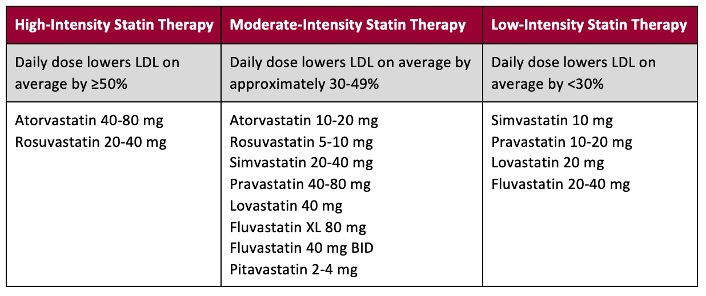
Cardiology management (Poll)
4-Does patient need antiplatelet agents?
- Yes
- No
Questions to the Cardiologist
5-Please elaborate on when this patient will require referral to a specialist cardiologist for further evaluation?
Any other tests that you think these patient needs or any salient points in the history that we need to take heed of?
At what stage would you consider adding in SGLT-2 inhibitors from a cardiac standpoint?
- At diagnosis of T2DM
- At diagnosis of heart failure in a T2DM patient
- Upon intensification for glycaemic control

Renal management (poll)
1-How would you approach this patient from a renal standpoint?
Would you increase this patient's blood pressure medication? (BP 134/88 mmHg)
- Yes
- No
Renal management (poll)
2-What is a target blood pressure on this patient?
- < 120/80 mmHg
- < 130/80 mmHg
- < 135/85 mmHg
- < 140/90 mmHg

Renal management (poll)
3-Assuming this man has normal BP (120/80 mmHg) but with micro/macroalbuminuria would u still prescribe an ACE-I or ARB?
- Yes
- No
- I don’t know

Questions to the Renal Physician
4-At what stage would you consider adding SGLT-2 inhibitors from a renal standpoint?
- At the diagnosis of T2DM
- At onset of albuminuria
- At identification of sustained decrease in eGFR < 90 ml/min/1.73m²

Questions to the Renal Physician
5-Please elaborate on when this patient will require referral to a specialist nephrologist for further evaluation?
Any other tests that you think these patient needs or any salient points in the history that we need to take heed of?

CASE 3
Madam C. Age: 38 years
- Presented with bilateral edema of her upper thighs over 1 week.
- Noted weight gain of 12 kg in one week.
- Past history: Gestational diabetes.

- Blood Pressure: normal
- Investigations done this visit
  - HbA1c: 13.4%
  - Serum creatinine: 122 umol/L
  - Urinary protein/creatinine ratio: 378 mg/mol
- You decide to refer her to see a renal physician.

Questions to the panel (CASE 3)
Madam C, 38 years, cont’d

For the Family Physician
Q1. What are your treatment goals for this patient?
Q2. What additional diagnostic and screening tests would you order for Madam C?
Q3. What would your initial management for Madam C be before she presents to the renal physician be?
Q4. How often would you monitor the renal parameters? glucose parameters?

For the Renal Physician
Q5. When would you discharge the patient back to primary care? What parameters and treatment would you ensure before this?

Additional Questions for Panel Discussion
- Which T2DM primary care patient to pay more attention to when managing? (e.g. UACR > 30, multiple risk factors)
- Which OADs should GPs be using for their patients?
- What to look out for to avoid side effects?

