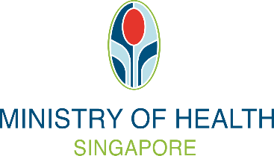
MEMO ON CONFIRMED COVID-19 INFECTION AND RECOVERY
FOR UNVACCINATED INDIVIDUALS

Full Name:
(As per NRIC/FIN/ Passport)
NRIC/FIN/Passport:
Country of Passport Issue:
(only if Passport No. provided)

To whom it may concern,

This is to certify that the abovementioned patient has tested positive on a SARS-CoV-2 (COVID-19) [Antigen Rapid Test (ART)/ Polymerase Chain Reaction (PCR) Test / Serology Test (Anti-N/Anti-S)] <to delete accordingly> on ____________ <insert date>.

2. Until further notice from MOH, this person is eligible to use this memo for vaccination-differentiated safe management measures after leaving self-isolation, for a period of 180 days starting from the abovementioned positive test date till __________ <insert date> (inclusive). Where the person had tested positive on ART or PCR, he/she has been advised to self-test ART-negative before leaving self-isolation and has agreed to do so.

3. For further details, please contact ____________________ <insert name of hospital / clinic (and branch if applicable), email, phone number>.

Thank you.

Stamp/ Signature/ Date

Name:
Designation:

